**A Project On Comprehensive Digital Marketing For Plum Goodness**

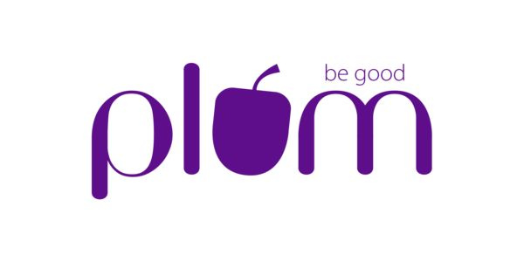

**Introduction:**

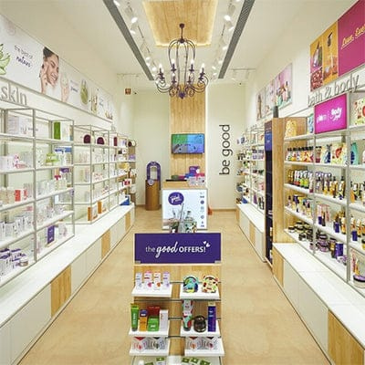

Plum Goodness is a sustainable and cruelty-free beauty and personal care brand founded in 2013. Committed to delivering effective products that benefit both skin and the planet, Plum has gained a strong reputation for its innovative approach to clean beauty.

The brand celebrates natural skin and uses high-quality natural ingredients combined with scientific research to create its products. Plum is proud to be 100% vegan and cruelty-free, with products free from harmful chemicals.

Offering a range of skincare, haircare, body care, and makeup products, Plum also owns a men’s self-care brand called PHY. The company’s core values include customer satisfaction, respect for employees, transparency, and sustainability.

Established with the vision of creating effective yet safe beauty solutions, Plum Goodness has carved a niche for itself by staying true to its ethos of being “clean, real, and good.”

Plum Goodness also emphasizes inclusivity, designing products suitable for different skin types, hair textures, and individual needs. Its range includes specific solutions such as acne-fighting skincare, hydration-focused products, and nourishing hair treatments, ensuring that no consumer feels left behind. This customer-centric approach is further amplified by its active online presence and a consistent engagement strategy that educates and inspires its audience.

As a brand that understands the importance of innovation, Plum Goodness frequently introduces new products that address emerging beauty trends and customer preferences. The company’s collaborations with influencers and its focus on digital marketing have allowed it to strengthen its presence in the competitive personal care market.

**Brand Study:**

Plum Goodness is a beauty and personal care brand that stands out for its commitment to sustainability, transparency, and clean beauty.

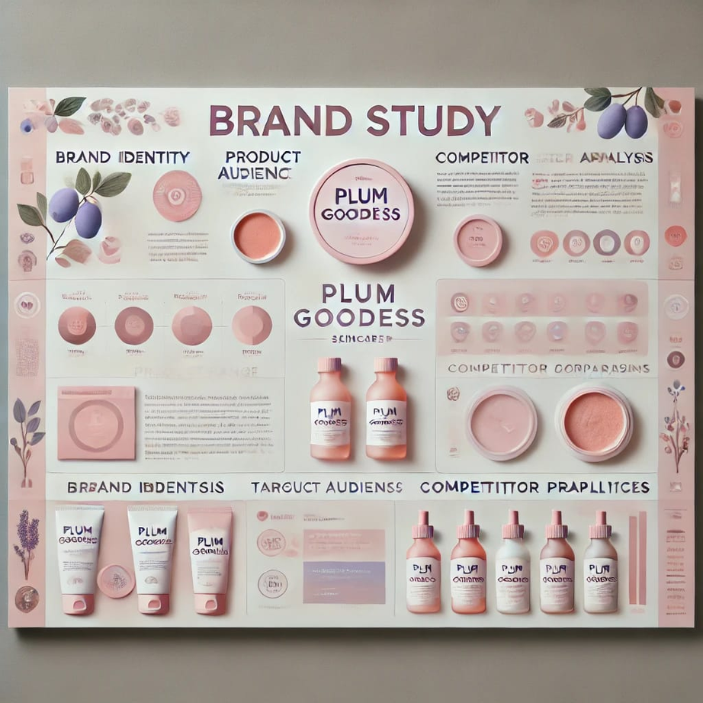

**Brand Overview:**

**Founded:** 2013 by Shankar Prasad.

**Core Values**: Sustainability, transparency, customer satisfaction, and respect for employees.

**Mission:** To create effective, cruelty-free products that are good for both the skin and the environment.

**Product Range:** Includes skincare, haircare, body care, and makeup products. They also own a men’s self-care brand called PHY

**Key Marketing Strategies:**

**1. Understanding the Audience:**

Focus on millennials and Gen Z who seek natural and ethical beauty solutions.

**2.Content Marketing:**

Informative content positions Plum as a leader in clean beauty, attracting organic traffic.

**3. Influencer Marketing:**

Collaborations with micro and macro-influencers to build trust and expand reach.

**4. SEO and Omnichannel Optimization:**

Strong digital presence with sales from platforms like Amazon, Flipkart, and Nykaa contributing 60-70% of revenue.

**5. Sustainability Initiatives:**

Programs like "Empties4Good" encourage customers to recycle used plastic bottles in exchange for rewards.

**Achievements:**

**Revenue Growth:** 50% increase in 2023, reaching approximately $25 million.

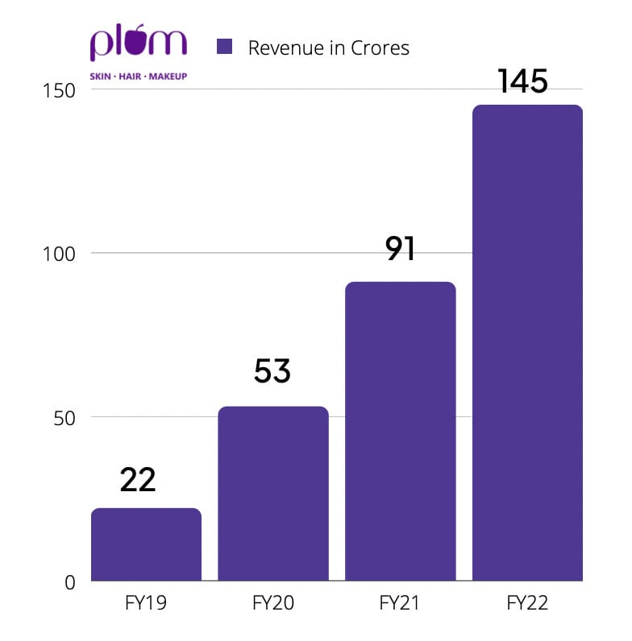

**Market** **Share:** Holds 15% of the Indian online beauty market .

**Customer Base:** Over 2 million active customers as of 2023.

**Unique Selling Points:**

100% vegan and cruelty-free products.

Free from harmful chemicals, focusing on natural ingredients combined with scientific research.

A pioneer in the Indian market for clean beauty, addressing gaps left by traditional and Ayurvedic brands.

**Business News:**

Plum Goodness secured a Series B funding of $20 million from Faering Capital, aimed at expanding their product range and market reach.

**Product Launch:**



In January 2024, Plum Goodness launched a new range of eco-friendly packaging for their skincare line, reinforcing their commitment to sustainability.

**Competitor Analysis of Plum Goodness:**

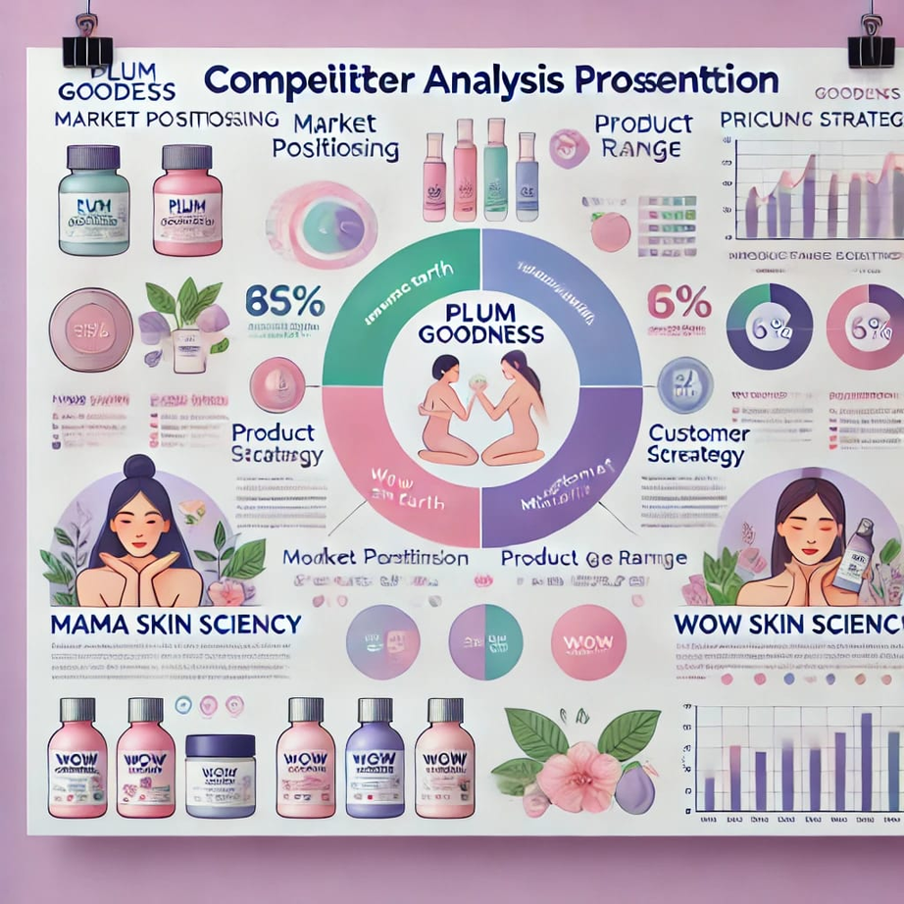

**1. Direct Competitors:**

Plum Goodness primarily competes with other brands in the natural and vegan skincare sector. Some key direct competitors include:

**Mamaearth:** Known for its toxin-free and eco-conscious formulations.

**Biotique:** Focused on Ayurvedic, herbal products with affordability as a key selling point.

**The Body Shop:** A globally recognized brand that emphasizes cruelty-free and natural ingredients.

**2. Product Portfolio Comparison:**

**Plum Goodness:** Offers skincare, hair care, and makeup products that are vegan and toxin-free. Flagship products include the Green Tea range for oily skin and Vitamin C serums.

**Mamaearth:** Focuses on eco-friendly products for babies, adults, and moms, such as their Ubtan face wash and sheet masks.

**Biotique:** Products center on Ayurvedic ingredients like neem and papaya, appealing to customers interested in herbal remedies.

**The Body Shop:** A wide range of products including skincare, hair care, and body care, with emphasis on ethically sourced ingredients.

**3. Pricing Strategy:**

- Plum Goodness offers mid-range pricing, appealing to millennials and Gen Z consumers seeking premium formulations at affordable rates.

- Mamaearth emphasizes affordability with occasional premium offerings.

- Biotique’s competitive pricing targets budget-conscious customers.

- The Body Shop positions itself as a premium brand with higher price points, suitable for a global audience.

**4. Marketing and Branding:**

**Plum Goodness:** Focused on vibrant, youthful branding, and transparency in formulations. Their influencer collaborations and social media presence align with their target audience of environmentally conscious consumers.

**Mamaearth:** Relies heavily on digital marketing, influencer tie-ups, and campaigns that emphasize family values.

**Biotique:** Uses traditional branding methods and relies on its Ayurvedic positioning.

**The Body Shop:** Emphasizes ethical and environmental commitments in its marketing strategies, often taking a stand on social issues.

**5. Customer Base:**

- Plum Goodness primarily targets eco-conscious millennials and Gen Z with a preference for vegan and cruelty-free products.

- Mamaearth appeals to families and young moms looking for gentle, toxin-free products.

- Biotique attracts customers interested in natural, herbal remedies.

- The Body Shop focuses on premium consumers who prioritize ethical beauty products.

**6. Distribution Channels:**

**Plum Goodness:** Available online through its official website, Amazon, Flipkart, and Nykaa. Physical presence includes department stores and dedicated kiosks in malls.

**Mamaearth:** Strong online presence with similar platforms and physical availability in grocery chains.

**Biotique:** Widely available in retail stores, pharmacies, and online platforms.

**The Body Shop:** Operates exclusive brand outlets along with online distribution.

**7. SWOT Analysis:**

**Plum Goodness:**

**Strengths:** Vegan formulations, strong social media presence, eco-friendly packaging.

**Weaknesses:** Limited global presence compared to competitors like The Body Shop.

**Opportunities:** Expansion into international markets; increasing demand for vegan skincare.

**Threats:** Growing competition in the eco-friendly cosmetics sector.

**Mamaearth:**

**Strength:** Strong family-focused marketing and affordability.

**Weaknesses:** May lack appeal to premium consumers.

**Opportunities:** Broadening product range.

**Threats:** Overlap with competitors in toxin-free skincare.

**Buyer’s/ Audience Persona for Plum Goodness:**

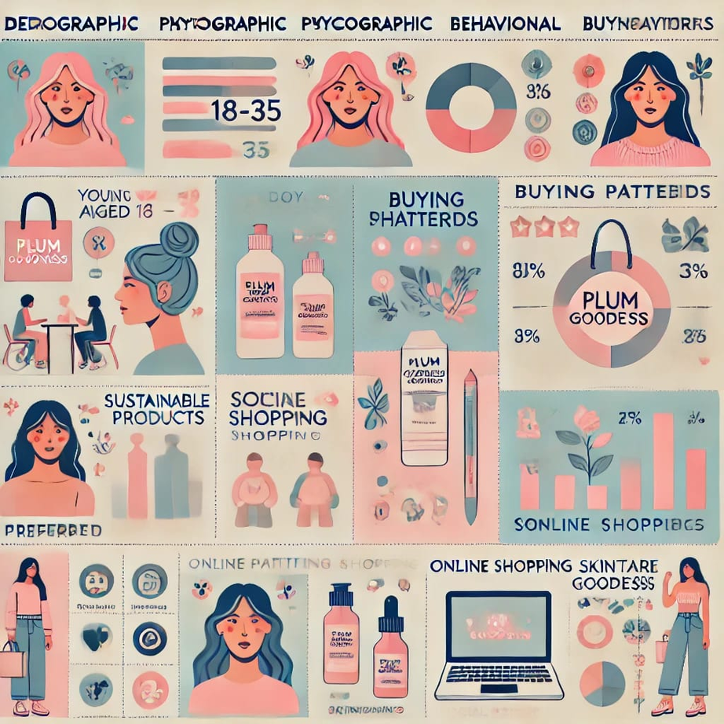

**1. Demographic Profile:**

**Age Group:** Primarily 18-35 years old (Gen Z and Millennials).

**Gender:** Predominantly female, but includes eco-conscious male buyers.

**Income Level:** Middle to upper-middle class with disposable income for mid-range products.

**Geographical Location:** Urban and semi-urban areas in India, with growing interest in international markets.

**2. Psychographic Profile:**

**Lifestyle:**Health-conscious, environmentally aware, and values self-care. These individuals prioritize cruelty-free, sustainable, and toxin-free products.

**Personality Traits:** Ambitious, socially responsible, and digitally savvy.

**Hobbies and Interests:** Skincare routines, wellness activities, yoga, makeup tutorials, and staying updated with skincare trends.

**Values:** Transparency, quality, and ethical sourcing.

**3. Behavioral Traits:**

**Buying Motivation:**

- Preference for vegan and cruelty-free skincare.

- Desire for high-quality products with natural formulations.

- Attraction to trendy, social media-endorsed brands.

**Buying Concerns:**

- Price sensitivity compared to alternatives.

- Concerns about product effectiveness and compatibility with skin types.

- Desire for detailed ingredient transparency.

**Decision-making Process:** Relies on online reviews, influencer recommendations, and peer opinions before making purchases.

**4. Online Presence and Social Media Habits:**



**Preferred Platforms:** Instagram, YouTube, and Pinterest.

**Behavior:**

- Follows skincare influencers and eco-friendly brands.

- Engages with skincare tutorials, product demos, and reviews.

- Participates in discussions about skincare tips and hacks.

**5. Preferred Brand Attributes:**

**Eco-friendly Packaging:** Buyers appreciate brands that reduce environmental impact.

**Ingredient Transparency:** Clear labeling of ingredients to avoid harmful chemicals.

**Community Engagement:** Buyers value brands that support social or environmental causes.

**Affordable Luxury:** They look for products that feel premium but remain within budget.

**SEO and Keyword Research:**

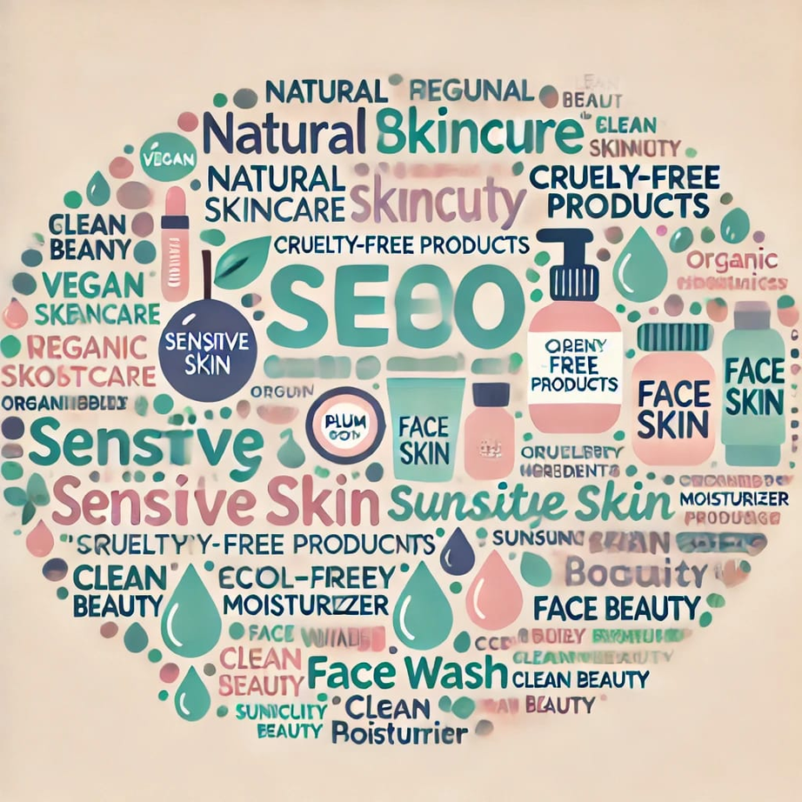

**SEO Audit:**

**The Power of SEO in Elevating Plum Goodness:**

In today's digital-first world, where customers often start their buying journey online, Search Engine Optimization (SEO) has become indispensable for brands like Plum Goodness. A robust SEO strategy not only enhances visibility on search engines but also connects the brand with its target audience.

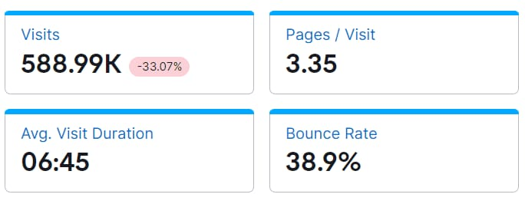

**Why SEO Matters for Plum Goodness:**

**1. Increased Brand:** Visibility With thousands of skincare brands vying for attention, SEO ensures that Plum Goodness stands out to eco-conscious, skincare-savvy consumers.

**2. Targeted Traffic:** By aligning with relevant search queries, the website can attract users genuinely interested in vegan and cruelty-free skincare.

**3.Cost-Effective Marketing:** Organic traffic is one of the most affordable ways to drive website visits and grow a loyal customer base

* **Create high-quality content that resonates with your audience. Ideas include:**

**Blog Posts:** Write articles about "The Benefits of Using Vegan Skincare Products" or "10 Must-Have Plum Goodness Products for a Natural Glow."

**Video Tutorials:** Share skincare tips using Plum Goodness products, optimized with SEO-friendly titles and descriptions.

**3. Technical SEO:**

**Ensure the website is optimized for:**

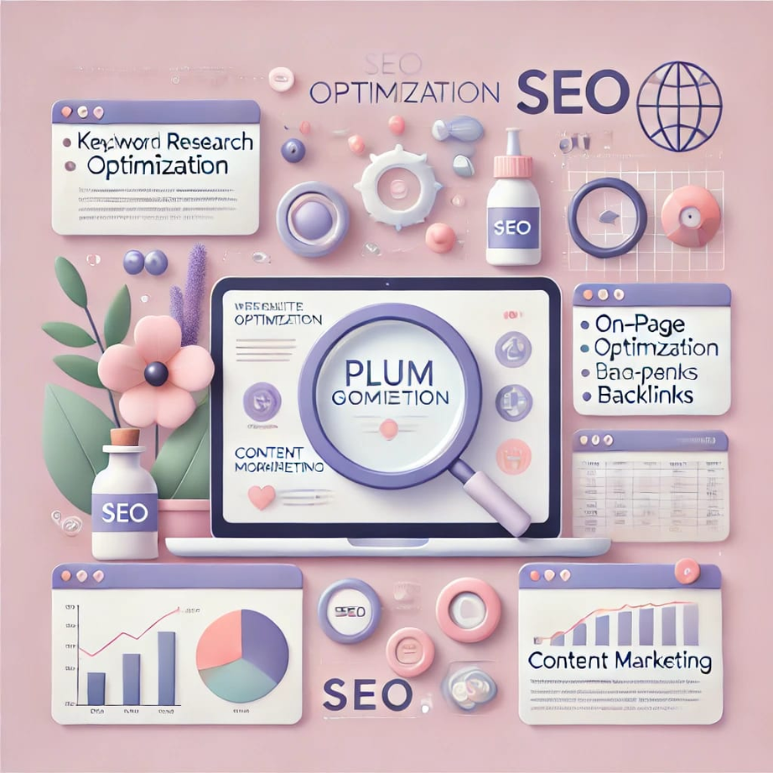

**Mobile Users:** With most users browsing on smartphones, Plum's website should offer a seamless mobile experience.

**Page Speed:** Optimize images and scripts to reduce load time.

**Meta Descriptions:** Write compelling, keyword-rich meta tags to improve click-through rates.

**4. Backlink Building:**

Collaborate with eco-lifestyle bloggers or skincare influencers to create authentic content that drives traffic back to Plum’s website.

**Keyword Research for Plum Goodness:**

Keyword research is the cornerstone of a successful SEO strategy, helping Plum Goodness connect with eco-conscious consumers searching for cruelty-free and vegan skincare products. Below are steps and insights into effective keyword research for the brand.

**1.Primary Keyword:**

These are high-ranking, competitive keywords that directly describe Plum Goodness's products and values. Examples:

- Vegan skincare

- Cruelty-free cosmetics

- Paraben-free beauty products

- Natural skincare for sensitive skin

**2. Long-Tail Keywords:**

These are more specific search terms that cater to niche markets or customer queries. They typically have lower competition but higher conversion potential. Examples:

- "Best cruelty-free skincare brands in India"

- "Vegan face wash for oily skin"

- "Affordable paraben-free moisturizers for dry skin"

- "How to create a skincare routine with cruelty-free products"

**3. Competitor Analysis:**

Study the keywords used by similar brands like:

- The Body Shop

- Forest Essentials

- Mamaearth

Identify the gaps where Plum Goodness can position itself uniquely.

**4. Audience-Centric Keywords:**

Use your audience personas to identify queries that resonate with the target market. Think of terms related to:

- Benefits of vegan beauty products

- Skincare tips for eco-friendly lifestyles

- Sustainable beauty routines

**5. SEO Tools for Refinement:**

Leverage tools like Google Keyword Planner, SEMrush, and Ubersuggest to:

- Identify high-ranking keywords.

- Check monthly search volumes and competition levels.

- Discover trending phrases in the beauty and wellness industry.

**6. Content Integration:**

After identifying relevant keywords, integrate them seamlessly into:

- Blog articles: E.g., "Top 5 Vegan Skincare Products for Radiant Skin."

- Product descriptions: Highlight unique selling points with targeted keywords.

- Meta descriptions, headings, and alt text: Improve visibility and click-through rates.

**on-page optimization for Plum Goodness:**

**Enhancing On-Page Optimization for Plum Goodness:**

On-page optimization plays a pivotal role in increasing Plum Goodness's visibility on search engines and connecting eco-conscious customers with their cruelty-free, vegan skincare products. By optimizing individual web pages, Plum Goodness can achieve higher rankings and attract targeted traffic. Here's a detailed outline to guide the process:

**1. Content Optimization:**

High-Quality Content: Develop engaging and informative content addressing audience needs. Topics could include:

- "Top Vegan Skincare Products for Radiant Skin"

- "Benefits of Cruelty-Free Beauty for the Planet"

**Keyword Integration:** Incorporate primary keywords like "vegan skincare" and long-tail keywords such as "best cruelty-free moisturizer for dry skin" naturally within the text.

**2. Title Tags and Meta Descriptions:**

**Title Tags:** Craft unique, keyword-rich titles like "Shop Cruelty-Free Beauty with Plum Goodness."

**Meta Descriptions:** Include a brief summary with a compelling call-to-action, e.g., "Discover Plum Goodness's paraben-free skincare products. Your vegan glow awaits!"

**3. Optimized URLs:**

- Create short, descriptive URLs such as:

- www.plumgoodness.com/vegan-skincare

- www.plumgoodness.com/natural-moisturizer-sensitive-skin

**4. Header Tags:**

- Structure pages with header tags to improve readability and SEO rankings:

- H1: "Explore Vegan Skincare with Plum Goodness"

- H2: "Why Choose Cruelty-Free Products?"

- H3: "Recommended Plum Products for Every Skin Type"

**5. Image Optimization:**

- Use descriptive filenames (e.g., plum-vitamin-c-moisturizer.jpg) and keyword-rich alt texts like "Plum Vitamin C Moisturizer for bright, glowing skin."

- Compress images to maintain quality and enhance load times.

**6. Internal Linking:**

- Guide visitors seamlessly through the website by linking blog posts to relevant product pages and vice versa.

**7. Mobile Responsiveness:**

- Optimize the website for mobile devices to ensure a smooth user experience.

**8. Page Load Speed:**

- Use tools like Google PageSpeed Insights to improve load times and ensure quick access to Plum's offerings.

**9. Structured Data:**

- Add schema markup for products to highlight information like prices, ratings, and availability directly in search results.

**Content and Marketing Strategy of Plum Goodness :**

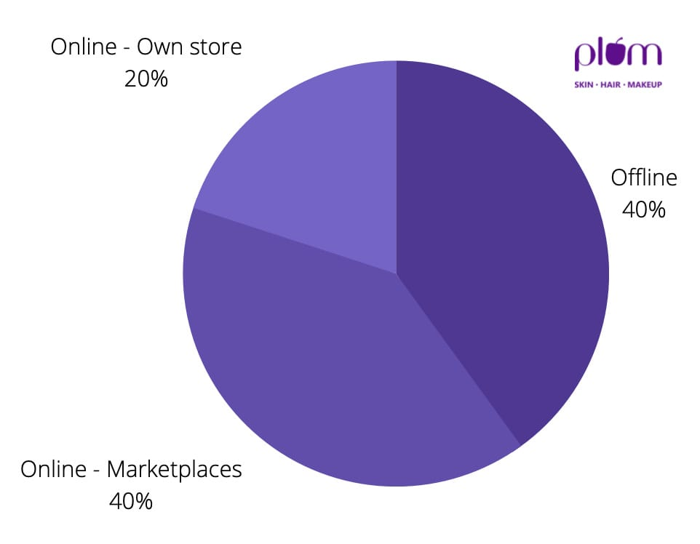

A business must have a strong marketing plan to flourish. Let’s explore the marketing strategy of Plum Goodness.

**Segmentation, Targeting, and Positioning**

Plum targets three primary customer groups:

**Young Women (18-35)**: Focusing on skincare, body care, and self-care products.

**Middle-Aged Women (35-50):** Catering to anti-ageing skincare needs.

**Young Men (18-35):** Offering a dedicated range under the ‘PHY’ brand.

Plum Goodness’s marketing strategy has successfully positioned itself as a cruelty-free, vegan, and sustainable beauty and self-care brand. The company tailors its products to meet the diverse needs of customers across different regions.

**Digital Marketing Strategy of Plum Goodness:**

Below is a list of important components utilised in Plum Goodness’s marketing strategy:

**Social Media Marketing:**

Plum has a strong social media presence, with Instagram being its biggest platform. The brand is also actively engaged on YouTube. Shivani Behl, Plum’s Chief Marketing Officer, highlights the effectiveness of social media in driving conversions compared to traditional paid advertising. She emphasises that social media is crucial for educating consumers about product ingredients.

Plum Goodness’s marketing strategy makes use of the following platforms:

**Instagram:** 651K Followers

**Facebook:** 240K Followers

**YouTube:** 28K Followers

Plum has a massive social media following. Their front-runner has always been “Instagram”.

Additionally, the marketing strategy of Plum Goodness ensures that its business is quite active on its YouTube account. Shivani Behl, the Chief Marketing Officer of Plum says “The kind of results that we get on social media conversions is far better than paid, the typically paid conversions that one optimises for. Social media is also used as a platform for educating the consumer about the different ingredients of their products”

**SEO Strategies:**

SEO rankings (Website’s position in search results) state that having fewer than 500 keywords is awful, having more than 1000 keywords is decent, and having more than 10,000 keywords would be exceptional. Plum Goodness has 95K+ organic keywords (Keywords searched without paid ads), which is an incredible amount. This indicates that Plum Goodness’s digital marketing is likely learning a lot.

Again, this is wonderful; the monthly traffic is about 272K+. Since these numbers are a result of the remarkable effort put into SERP results (Free search engine rankings), Plum Goodness’s marketing strategy is on the correct track and will keep expanding in this area.

**Influencer Marketing:**

Forget billboards, Plum’s advertising is all about the power of persuasion by your favorite social media stars! Instead of generic ads, Plum leverages influencers with massive followings who can spread the buzz about their products. Since people trust their recommendations, influencers become the secret weapon influencing what ends up in your shopping cart.

Plum Goodness’s marketing strategy makes excellent use of this and works with social media influencers to promote their goods and spread awareness.

Plum has collaborated with many influencers over the years. Some of them are Mithila Parkar, Alfiya Karim Khan, Rashmika Mandanna and Vipasha Malhotra. This has proven to be the best marketing strategy for Plum Goodness as this helped improve their customer base and also made their potential customers trust their products.

**E-commerce Strategies:**

Plum Goodness provides an online E-commerce portal to their customers, through which they can order products, and track their orders. Their products are also available on retail giants like Shoppers Stop, Nykaa, Flipkart, and Amazon.

Plum Goodness also has a section called the ‘**99 Store**’ which offers a discount on a few products. Customers can buy products at **up to 45% discount** which usually ends up at just **INR 99** under this section.

**Mobile Apps:**

Mobile Applications are usually better when it comes to shopping online due to their user-friendly interface and easy access. Plum Goodness, however, has not yet launched a mobile application. All their business comes through their website only.

**Content Marketing Strategies:**

The company produces a tonne of educational content for several platforms that cover a wide range of skincare-related topics. They post skincare tips, routines, product descriptions, etc on their YouTube channel.

Plum Goodness’s marketing strategy utilises a lot of live streams on Instagram with its clients to discuss holistic beauty generally and recruits dermatologists, fitness professionals, and nutritionists for the purpose.

**Content Creation and Curation for Plum Goodness:**

Content creation and curation are essential parts of Plum Goodness’ digital marketing strategy. The brand focuses on building a strong online presence through authentic, informative, and engaging content that resonates with its audience.

**1. Content Creation:**

Content creation involves generating original content that reflects the brand’s values, products, and messaging. For Plum Goodness, content creation should align with the brand's focus on clean beauty, sustainability, and cruelty-free products.

**a) Post Creation:**

**Platform-Specific Content:** Create platform-optimized posts for Instagram, Facebook, and YouTube.

**Product Showcases:** Highlight product benefits, usage tips, and tutorials.

**User-Generated Content (UGC):** Encourage customers to share their experiences with Plum products.

**Educational Content:** Share skincare tips, ingredient breakdowns, and routines.

**Behind-the-Scenes:** Showcase the brand's sustainability efforts and ethical sourcing.

**b) Designs/Video Editing:**

**Visual Storytelling:** Create visually appealing product videos, GIFs, and reels.

**Interactive Designs:** Develop infographics, carousels, and animated videos.

**Aesthetic Consistency:** Maintain the brand’s pastel-toned, clean aesthetic across all content.

**Before-and-After Visuals:** Demonstrate product effectiveness using authentic transformations.

**c) Social Media Ad Campaigns:**

**Targeted Campaigns:** Run ad campaigns on Instagram, YouTube, and Facebook targeting skincare enthusiasts.

**Influencer Collaborations:** Partner with beauty influencers for authentic product reviews.

**Seasonal Campaigns**: Create content for festivals, skincare routines, or special offers.

**Promotional Videos:** Feature limited-time discounts and new product launches.

**d) Email Ad Campaigns:**

**Personalized Newsletters:** Send skincare tips and product recommendations based on customer preferences.

**Product Announcements:** Inform subscribers about new arrivals, exclusive sales, or upcoming events.

**Customer Stories:** Feature real customer testimonials in emails to build trust.

**Re-Engagement Emails:** Target inactive users with compelling offers.

**2. Content Curation:**

Content curation involves selecting and sharing relevant content created by others, including industry news, skincare trends, and user-generated content. For Plum Goodness, this means curating content that aligns with its brand values.

**a) Industry Trends and News:**

Curate updates on clean beauty trends, ingredient innovations, and sustainable practices.

Share expert opinions and dermatologists’ insights on skincare.

**b) User-Generated Content (UGC):**

Feature customer reviews, unboxing videos, and skincare routines using Plum products.

Create a dedicated hashtag like #PlumLove to aggregate user content.

**c) Influencer and Blogger Collaborations:**

Curate testimonials and tutorials from beauty bloggers and influencers.

Share influencer content that aligns with Plum’s philosophy of natural beauty.

**d) Partnered Content:**

Collaborate with sustainability advocates to share informative content about eco-friendly beauty choices.

Curate articles, reports, and videos discussing ethical beauty practices.

A well-balanced content creation and curation strategy will help Plum Goodness maintain an authentic brand image, foster customer loyalty, and engage its target audience effectively.

**Marketing and Advertising Campaigns Designed by Plum Goodness’s Marketing Strategy:**

The advertisement and marketing campaigns of Plum Goodness revolve around its tagline. Clean. Real. Good. Plum wants to take it a step further and develop their definition of ‘clean skincare’ so that it may serve as a standard for skincare research that its clients can use to compare and contrast their options.

**1. Talk Clean to Me**



This Plum advertising campaign was designed to educate people and it points out products that are made without toxic and skin-damaging ingredients, but their in-progress list goes a step further by ensuring that they are open and honest with their customers at every stage of the process and keeping our promise to stay clean by actively working to uphold it.

**2. Like a Mother**



Here, this Plum advertising campaign garnered around 3 lakh+ impressions on social media. It was a Mother’s Day campaign where Plum invited their audience to appreciate motherly figures in their lives. All the audience had to do was follow their Instagram page, tag motherly figures in their lives and get a chance to avail a sweet surprise from Plum. It was a huge success as it reached so many people on the internet.

**3. Plum Squad**

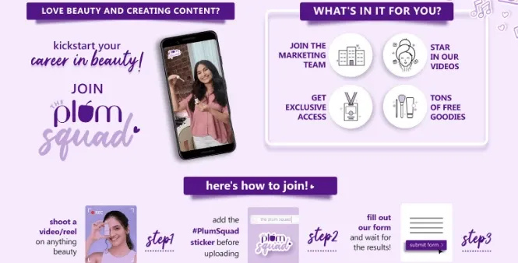

This campaign was an invitation to collaborators from all over India to join the Plum Goodness family and be their Brand Ambassador.

This marketing strategy of Plum Goodness gained a huge engagement and they received numerous entries from around the country. It allowed Plum to step up its influencer marketing game and also allowed people with low reach on social media to be seen and heard.

**Top Competitors That Influence the Marketing Strategy of Plum Goodness**

Plum Goodness is not the only brand that dominates the skincare industry. There are many other players that can have a huge impact on Plum Goodness’s marketing strategy:

**The Body Shop:** This company is known for offering its ethical and sustainable beauty products.

**Forest Essentials:** Luxury Ayurvedic skincare brand.

**Mamaearth:** Focuses on toxin-free and natural products.

**WOW Skin Science:** Offers a range of natural and health-focused beauty products.

**Biotique:** Combines ancient Ayurveda with modern science for skincare solutions.

**Products Of Plum Goodness :**

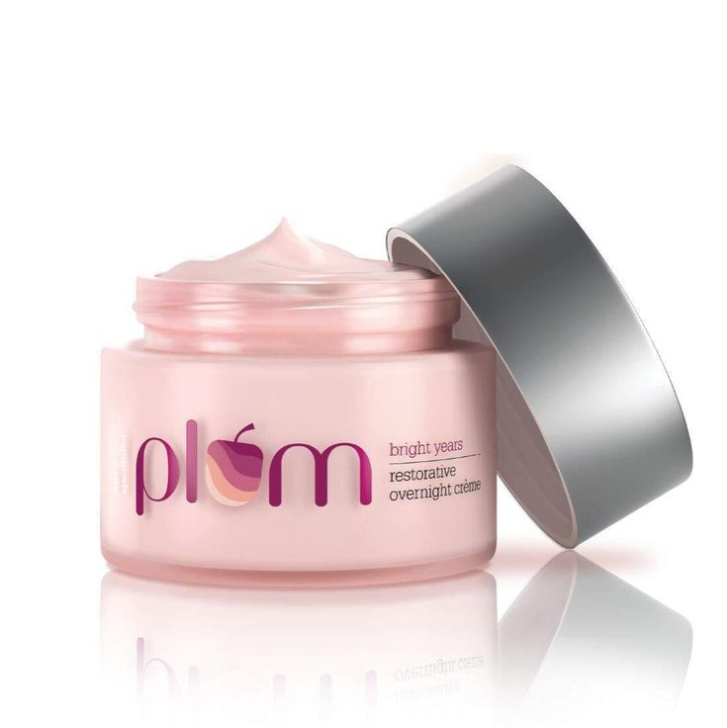



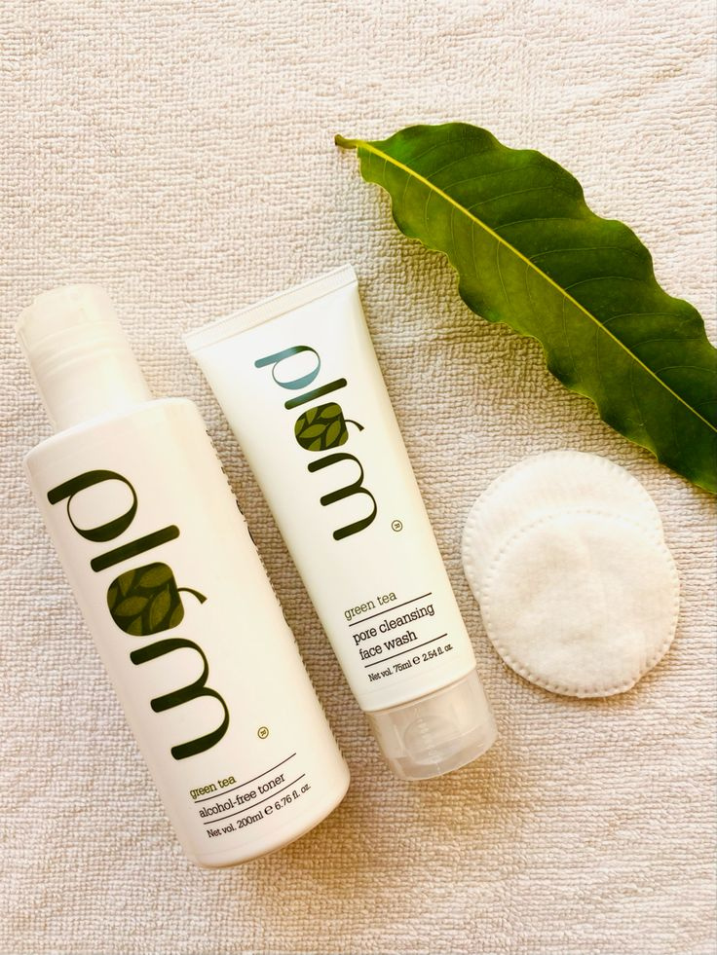



**Conclusion**

The brand not only sells but also educates people about clean and safe beauty products. One of the best features of Plum Goodness is its transparency in the raw material used for the production of each product. Also, the positive customer reviews from all over the country are proof that the company is doing very well in the industry.

The marketing strategy of Plum Goodness is top-notch at this point. Their campaigns create a sense of value in the customer’s mind. They are using every possible digital marketing strategy to stay relevant in today’s world.

**Project done by:**

**Name : Shaik Aqueela Taslim**

**Hallticket no. : 22356014007**

**E -MAIL I’d : aqueelataslim@gmail.com**

**College name : Vasavi Mahila Kalasala**

